Create SSIS package for below functionalities.  
Copy:---Copy file from source path to achieve path  
Move:---move file from source path to achieve path(Deleted file in source path)  
Delete: Delete file from source path  
  
Copy Directory  
Create Directory  
Delete Directory  
Move Directory  
Rename File

Create folder name with TEMP

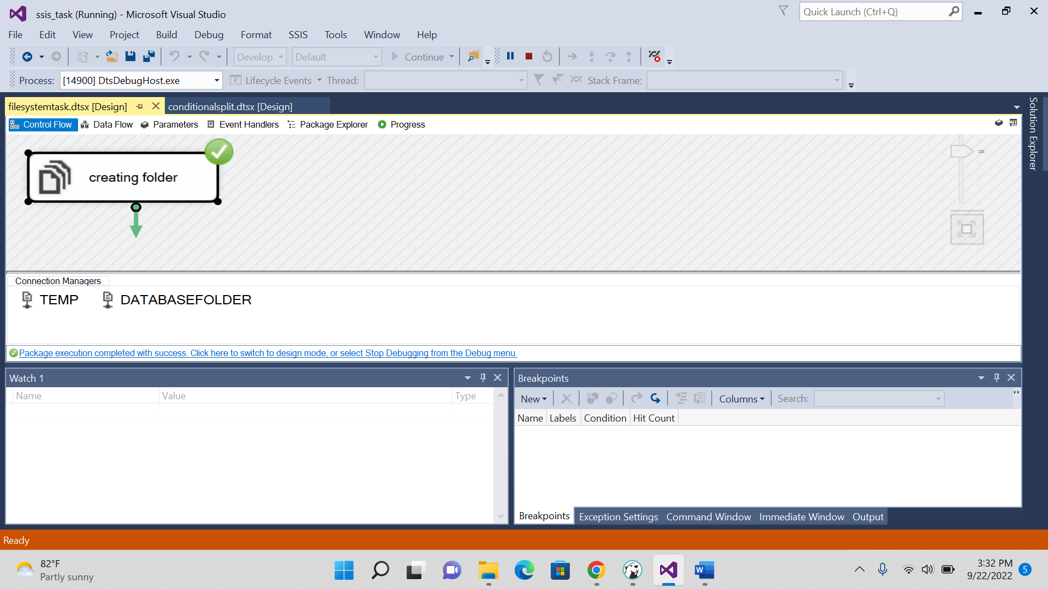

2.DELETE FOLDER

3.COPY DIRECTORY

4 DELETE DIRECTORY CONTENT

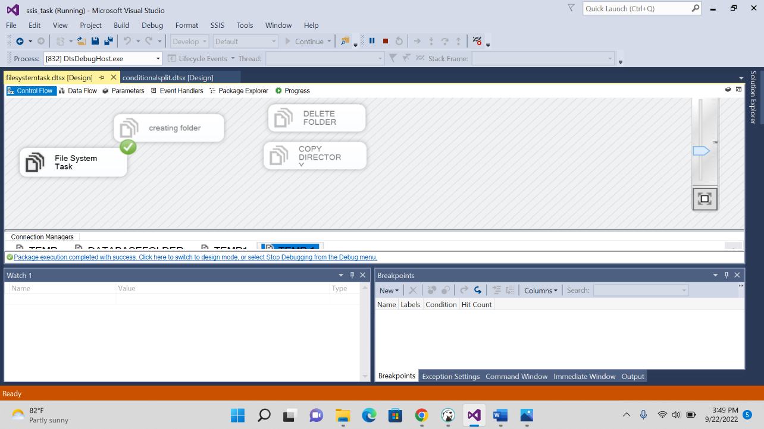

5.COPY FILES

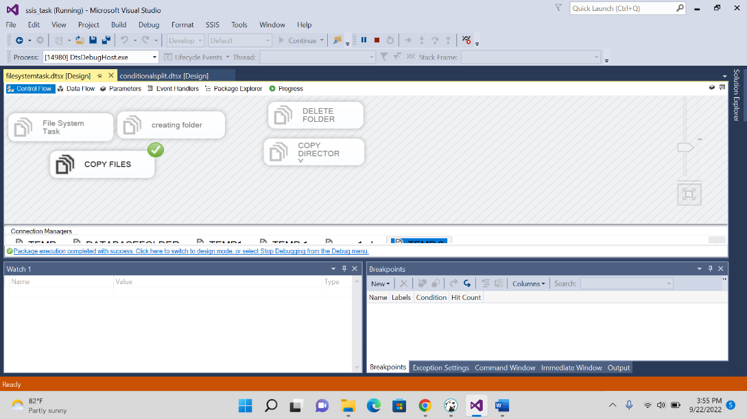

6.DELETE FILES

